Proof of Concept

# 1. Introduction

The Advanced Media Library (AML) system aims to modernize the management and operational capabilities of libraries by introducing digital solutions that enhance user and administrative functions. This section outlines the purpose, scope, and objectives of the POC, detailing the functionalities demonstrated and the technical solutions employed in the prototype.

# 2. Architecture

**2.1 Context Diagram (Level 1)**

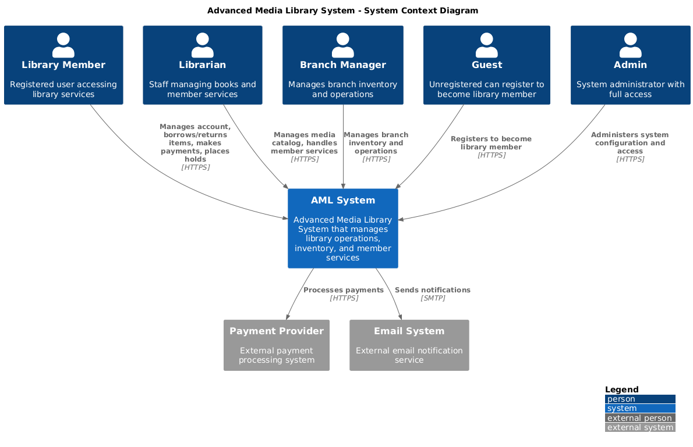**2.1 Web Application Prototype for Advanced Media Library**

Figure 2.1: Context Diagram

**2.2 Container Diagram (Level 2)**

Figure 2.2: Container Diagram

**2.2 Component Diagram (Level 3)**

Figure 1.2: Component Diagram

**2.4 Code Diagrams (Level 4)**

**2.4.1 Structural Diagrams**

## A screenshot of a computer program Description automatically generated2.4.1.1 Auth Service

Figure 2.4.1.1: Auth Service

## A diagram of a service Description automatically generated.2.4.1.2 Media Service

Figure 2.4.1.2 Media Service

**2.4.1.3 Loan Service**

Figure 2.4.1.3: Loan Service

**2.4.1.4 Payment Service**

Figure 2.4.1.4: Payment Service

**2.4.1.5 User Registration and Management**

Figure 2.4.1.5: Inventory Service

**2.4.2 Behavioural Diagrams**

Figure 3: Behavioural Diagram

# 3. Core Functional Demonstrations (Use Cases)

**2.1 Web Application Prototype for Advanced Media Library**

Our project is encapsulated in a web application prototype developed using Angular for the front-end and MySQL for the back-end, with local hosting facilitating real-time development adjustments. This application serves as an interactive demonstration tool, specifically designed to showcase the implementation of our defined use cases. It provides a functional simulation of user interactions such as registration, account management, media searches, and transaction processing within a library management context. This prototype not only helps validate the practical application of our software architecture but also allows us to conduct testing and refine functionalities based on these tests and user feedback in the future.

## 2.1.1 User Registration and Management

**Purpose:** To provide a seamless onboarding experience for new users and to facilitate easy management of user profiles.

**Functionality:** The application supports new user registration, where users can enter personal details, set up login credentials, and confirm account creation. It also enables profile management, allowing users to update personal information and manage account settings.

## 2.1.2 Manage Library Account Online

Purpose: To enable library members to independently manage their loans, holds, and account details through the online platform.

Functionality: Members can view current loans, renew books, place holds on desired media, and track the status of borrowed items, providing a comprehensive management interface accessible via web or mobile app.

## 2.1.3 Search for Media

Purpose: To enhance the discovery of library resources by providing a powerful and efficient search tool that caters to diverse user needs.

Functionality: Features a sophisticated search engine that allows users to find books and other media based on various criteria such as title, author, and genre. It optimizes user experience by delivering quick and accurate search results.

## 2.1.4 Flexible Payment Options for Library Members

Purpose: To offer multiple convenient payment options for library fees, fines, and subscriptions, enhancing the overall user experience.

Functionality: Integrates a comprehensive payment system that allows members to settle dues using various methods, including online transactions via credit card or mobile wallet. This system is secure and updates the user's account status immediately upon transaction completion.

## 2.1.5 Adding New Books to the System

Purpose: To streamline the process of expanding the library's collection by facilitating easy addition of new books.

Functionality: Provides a dual interface for single and bulk book additions, allowing librarians to input or upload book details effectively. This ensures that new additions are promptly available for borrowing and are accurately tracked in the inventory system.

## 2.1.6 Media Inventory Management

Purpose: To enable branch managers and administrative staff to efficiently oversee and update the media inventory across various library branches.

Functionality: This administrative tool allows branch managers to view comprehensive media inventory details, execute real-time tracking, and manage transfers between branches. The system supports adding new items, updating existing media details, and coordinating the logistics of media distribution, ensuring that inventory is accurately maintained and readily accessible across all locations.

# 4. Technical Viability

**Database and API Functionality:** The POC confirms the effective integration between the Angular-based frontend and MySQL database, ensuring that actions like user registrations, media searches, and transaction processes are properly executed through robust APIs. Testing has shown that the system interactions are seamless and efficient, supporting both real-time data processing and retrieval.

**Security Measures**: Preliminary security protocols have been implemented to protect user data and ensure system integrity. These measures include secure login processes, data encryption, and compliance with data protection regulations. Further security testing and enhancements are planned as part of the system's ongoing development.

# 5. User Interface Usability

**Interactive Prototyping and User Interface Refinement**: The design process leverages interactive prototypes to facilitate continuous refinement of the user interface, simulating real user interactions to gather critical insights into usability, navigability, and overall user experience. We are committed to iteratively improving the system based on user feedback, aiming to enhance the functionality and accessibility of the library management system. Ensuring the system is intuitive and meets the needs of library patrons and staff is paramount.

**Training and User Feedback Incorporation**: As the project progresses, we plan to implement training sessions for library staff and collect their feedback to continuously improve the documentation and system interfaces. This ongoing support mechanism will adapt to user needs and technological advancements, maintaining the system's relevance and ease of use.

# 6. Compliance and Standards

**Accessibility Compliance** As we develop the user interface, ensuring accessibility compliance will be a key focus. We aim to design our system following standard accessibility guidelines, including considerations for screen reader compatibility, keyboard navigability, and adequate color contrast. Throughout the development process, we will engage in rigorous testing and iterative improvements to ensure our system is accessible to all users, including those with disabilities.

**Web Content Accessibility Guidelines (WCAG)**: The system will be designed to meet WCAG 2.1 Level AA criteria, ensuring that content is accessible to a broader range of people with disabilities, including accommodations for auditory, cognitive, neurological, physical, speech, and visual challenges.

# 7. Documentation and Support

**Architecture Decision Records (ADRs)**: We maintain detailed ADRs that document the architectural decisions made throughout the project. These records provide insight into the rationale behind each decision, ensuring that future development aligns with the established architectural vision and principles.

**GitHub Code Repository**: The project's codebase is hosted on GitHub, providing version control and collaborative tools that facilitate efficient coding practices. This repository includes well-commented code and README files that explain the setup, configuration, and basic use of the system, making it accessible for new developers and stakeholders.

# 8. Future Enhancements

**Mobile to Web Expansion**: Initially launching with a robust mobile application to ensure accessibility on the go, future plans include expanding these functionalities to a comprehensive web platform. This transition will cater to users who prefer desktop access, providing a seamless experience between mobile and web interfaces.

**Implementation of AI for Customized Recommendations**: Integrate artificial intelligence to analyse user behaviour and borrowing patterns, enabling the system to offer personalized book and media recommendations. This would enhance user engagement and satisfaction by tailoring suggestions to individual preferences.

**Adding More Functionalities**: Continuous innovation is key to keeping the library system relevant and engaging. Future updates will include new functionalities like event management tools for library-hosted events, virtual tours of library facilities and resources, and interactive tutorials to help users navigate and utilize the library more effectively.

**Real-time Inventory Management with IoT**: Employ Internet of Things (IoT) technology to track physical resources in real-time, allowing for instant updates on item availability and location within the library. This enhancement will streamline operations and improve the accuracy of inventory management, reducing errors and saving time for both staff and patrons.

**Community Engagement Features**: Develop tools within the app to facilitate community engagement, such as organizing and promoting library events, workshops, and book clubs. Features could include event registration, calendar integration, and interactive notifications to keep the community informed and engaged.

# 9. Conclusion

The viability of the Advanced Media Library system has been effectively validated through this series of demonstrations, showcasing robust functionalities and pinpointing areas for further refinement. The prototype confirms that our architectural choices are well-suited for the expanding needs of modern library operations. Moving forward, we will focus on enhancing these features and broadening the system's accessibility by introducing web-based access for users. Our ongoing development will leverage user feedback to continually improve the service delivery and overall user experience within the library system.

# 10. References

Strauss, L. (2024, May 1). *What is a proof of concept? And how to write one (with template)*. Retrieved from Zapier.